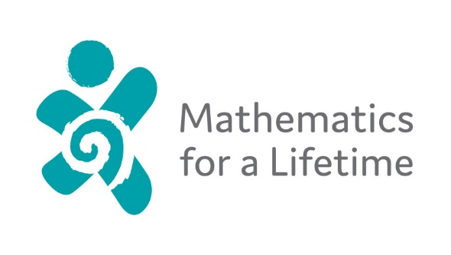
Mathematics for a Lifetime Charitable Trust, CC53784
Board members;
Jean McKenzie, Chairperson
Rochelle Old, Board member
Kevin Butler, Board member
Susan Brennan, Treasurer
New Board member:
Jay Ballantyne

Chairperson’s Report, AGM 2019
Upon my reflection on our past year I began to frame all my thoughts into sets of numbers which seems very relevant for Mathematics for a Lifetime! The following are statistics which shows MFALs effectiveness and dedication to making a difference for kids. The statistics are based on facts from the launch in 2017 through to this AGM and as a ‘young’ Trust this information is very interesting…
69 Young people have been approved and supported in Mathematics tuition throughout both Primary and Secondary level
112 chunks (school terms) of learning time have been used for this purpose
5 applications have been declined.
7 Approved Tutors are in place in Hamilton x2, Cambridge, Te Awamutu, Manawatu, Taupo and Hokitika. All have accepted and signed annual Approved Tutor Agreements.
$50, 000 is the financial cap we consider for applications as their annual income.
$26,000 is the average income in the applications.
2 business Awards were achieved in 2018 at the Waipa Business Awards – New and Emerging Excellence in Business plus the Judges Award for Sustainability and Contribution to Community.
3 businesses volunteered their time to create an updated website now at an International level. Rocketspark, The Good PA and Quick Brown Fox Communications.
7 donations have been made at the Pavlova level – above $1295
4 donations have been made at Jellytip level – above or at $350
A Large number have been made at Chocolate fish level as a general donation
10 donations of time have been offered at the Jet Plane level. This does not include a large number of Volunteer Waikato helpers who have contributed in a range of ways.
Numerous presentations have been made with speaking engagements, meetings, promotions and conversations.
To say that the past years since the launch have been a learning curve would be the understatement of the year! The range of people MFAL touches is significant as we grow in strength and reputation. Winning the two Awards at the Waipa Business Awards was a reflection of the importance we place on the structure of our Organisation recognised by experienced Judges. As an example the data base designed by Kevin Butler, Board member, continues to exceed its original purpose.
A major and personal highlight was presenting at Trinity College, Dublin University in June this year. I was greatly encouraged by the positive response from Cliona Hannon, Director of the Trinity College Access (TAP) programme, run by Trinity College Dublin. It was a privilege and great experience to meet with Cliona for a full hour and to know that someone tens of thousands of kilometres away in Ireland also share your idea simply because education is the key to a better life and our children deserve the absolute best start in life.
My key word for this new financial year is collaboration and its importance. Not only with Sponsors and Donators but families, people of influence and the young people themselves.
I would like to thank you all for being part of the MFAL Board with your contributions. Your voluntary work is so important to the success of MFAL.
We continue to ‘Transform lives’.
Jean McKenzie
Chairperson / Founder
